 DEPARTMENT OF INFORMATION & COMMUNICATION TECHNOLOGY

MANIPAL INSTITUTE OF TECHNOLOGY

(A Constituent College of Manipal University)

MANIPAL – 576104, KARNATAKA, INDIA

17th Nov 2016

AJP PROJECT REPORT

BTECH IT VII SEMESTER

**HOSTEL RESERVATION SYSTEM**

Submitted by

Yousuf Ali Imam Reg no: 130911092 (09)

Aman Bakshi Reg no: 130911136 (12)

|  |
| --- |
| **CONTENTS**   1. Introduction………….…………………………………………………………...3 2. Design……………………………………………………………………………4 3. Implementation……… ………………………………………………………….6 4. Result……………………………………………………………………………11 5. Conclusion………………………………………………………………………14 6. References………………………………………………………………………15   **INTRODUCTION** |
| This system will be designed taking into account the practical need to solve huge amount of problems faced while allocating and booking hostel rooms, using current system available. Moreover, it provides an organized way to book, view, allocate and make changes whenever required and possible. Its design concentrates on 2 types of users:   1. Administrator 2. User   This system follows a typical event flow seen in such a system. The system mainly is from the user point of view. However, administer has been given special privileges to allocate rooms and easily manage user requests.  Firstly, the user has to register by providing his/her details. After registering, user can login using his/her username and password. Then after login, they can view the hostels available and give their preference accordingly. Every user is allotted the hostel room only after administrator’s approval.  The administrator’s work is to check the preference given by the user and allocate the rooms accordingly. In case of any change-of-hostel requests, the user can send a message to the administrator requesting the same, the administrator can resolve any further issues after receiving the request.  The GUI is developed using Spring MVC, Java Spring Framework, Servlets and MySQL is used for the database operations. |

**DESIGN**

The whole project has been designed using the Java Spring Framework and using JDBC to connect with the MySQL database.

Java Spring MVC:

**MVC** is one of three ASP.NET programming models. **MVC** is a framework for building web applications using a **MVC** (**Model View Controller**) design: The Model represents the application core (for instance a list of database records). The View displays the data (the database records).

The Spring web MVC framework provides model-view-controller architecture and ready components that can be used to develop flexible and loosely coupled web applications. The MVC pattern results in separating the different aspects of the application (input logic, business logic, and UI logic), while providing a loose coupling between these elements.

* The **Model** encapsulates the application data and in general they will consist of POJO.
* The **View** is responsible for rendering the model data and in general it generates HTML output that the client's browser can interpret.
* The **Controller** is responsible for processing user requests and building appropriate model and passes it to the view for rendering.

Java Spring Framework:

It can be thought of as a framework of frameworks because it provides support to various frameworks such as Struts, Hibernate, Tapestry, EJB, JSF etc. The framework, in broader sense, can be defined as a structure where we find solution of the various technical problems.

The Spring framework comprises several modules such as IOC, AOP, DAO, Context, ORM, WEB MVC.

JDBC:

JDBC stands for Java Database Connectivity, which is a standard Java API for database independent connectivity between the Java programming language and a wide range of databases. The JDBC library includes APIs for each of the tasks commonly associated with database usage:

• Making a connection to a database

• Creating SQL or MySQL statements

• Executing that SQL or MySQL queries in the database

• Viewing & Modifying the resulting records

Here, we first have a welcome page which is used for user login and registration. After Login, the user gets an option to either apply for hostels or edit his/her previous choices .

If the user chooses to apply for hostels the same preferences will be reflected in his/her profile.

After completing each of the given operation, the user will be getting a confirmation of the task being completed successfully.

Database Schema:

**Login1** (

username varchar(20),

password varchar(20),

filled varchar(20),

alloted varchar(20)

);

**stdetails**

(

username varchar(20),

name varchar(20),

age int,

regnum varchar(20),

yearofstudy varchar(20),

emailid varchar(50),

p1 varchar(20),

p2 varchar(20),

p3 varchar(20),

alloted varchar(20)

);

**IMPLEMENTATION**

Index.jsp:

<%@page contentType="text/html" pageEncoding="UTF-8"%>

<!DOCTYPE HTML PUBLIC "-//W3C//DTD HTML 4.01 Transitional//EN"

"http://www.w3.org/TR/html4/loose.dtd">

<%@taglib uri="http://www.springframework.org/tags/form" prefix="form"%>

<html>

<head>

<meta http-equiv="Content-Type" content="text/html; charset=UTF-8">

<title>Welcome to Hostel Management System</title>

<style>

body {

background-image: url("img/bgr.jpg");}

h1 {color: brown;

font-family: sans-serif;}

p {color: black;

font-family: sans-serif;

font-size: 12px;

}

input[type=submit] {

font-size: 14px;

font-family: sans-serif;

}

td{font-family: sans-serif;

font-size: 12px;

}

</style>

</head>

<body>

<div align="center"><h1>Hostel Management System</h1></div>

<form:form method="POST" action="/HostelManagementSystem/addUser.htm">

<div align="center">

<table>

<tr>

<td >User Name</td>

<td><input type="text" name="userName" /></td>

</tr>

<tr>

<td>Password</td>

<td><input type="password" name="password" /></td>

</tr>

<tr>

<td></td>

<td><input type="submit" value="Submit" /></td>

</tr>

</table>

<div style="color: red">${error}</div>

</div>

<div>

${message}

</div>

</form:form>

<br>

<br>

<br>

<div align="center">

<p>Not Registered? Register here, to apply for hostels!</p>

<form action="RegisterServlet" method="get" >

<input type="submit" value="Register" align="center">

</form></div>

</body>

</html>

StudentMapper.java:

/*

* To change this license header, choose License Headers in Project Properties.

* To change this template file, choose Tools | Templates

* and open the template in the editor.

*/

package com.aman.JDBC;

import com.aman.POJO.Student;

import com.aman.POJO.UserLogin;

import java.sql.ResultSet;

import java.sql.SQLException;

import org.springframework.jdbc.core.ResultSetExtractor;

import org.springframework.jdbc.core.RowMapper;

/**

*

* @author Aman

*/

class StudentMapper implements RowMapper<Student> {

@Override

public Student mapRow(ResultSet rs, int i) throws SQLException {

Student mStudent= new Student();

mStudent.setUsername(rs.getString("username"));

mStudent.setName(rs.getString("name"));

mStudent.setAge(rs.getInt("age"));

mStudent.setRegnum(rs.getString("regnum"));

mStudent.setYearofstudy(rs.getString("yearofstudy"));

mStudent.setEmailid(rs.getString("emailid"));

mStudent.setP1(rs.getString("p1"));

mStudent.setP2(rs.getString("p2"));

mStudent.setP3(rs.getString("p3"));

mStudent.setAlloted(rs.getString("alloted"));

return mStudent;

//throw new UnsupportedOperationException("Not supported yet."); //To change body of generated methods, choose Tools | Templates.

}

}

RegisterServlet.java:

/*

* To change this license header, choose License Headers in Project Properties.

* To change this template file, choose Tools | Templates

* and open the template in the editor.

*/

package com.aman.classes;

import java.io.IOException;

import java.io.PrintWriter;

import javax.servlet.ServletException;

import javax.servlet.http.HttpServlet;

import javax.servlet.http.HttpServletRequest;

import javax.servlet.http.HttpServletResponse;

/**

*

* @author Aman

*/

public class RegisterServlet extends HttpServlet {

/**

* Processes requests for both HTTP <code>GET</code> and <code>POST</code>

* methods.

*

* @param request servlet request

* @param response servlet response

* @throws ServletException if a servlet-specific error occurs

* @throws IOException if an I/O error occurs

*/

protected void processRequest(HttpServletRequest request, HttpServletResponse response)

throws ServletException, IOException {

response.setContentType("text/html;charset=UTF-8");

try (PrintWriter out = response.getWriter()) {

/* TODO output your page here. You may use following sample code. */

out.println("<!DOCTYPE html>");

out.println("<html>");

out.println("<head>");

out.println("<title>Servlet RegisterServlet</title>");

out.println("</head>");

out.println("<body>");

out.println("<h1>Servlet RegisterServlet at " + request.getContextPath() + "</h1>");

out.println("</body>");

out.println("</html>");

}

}

// <editor-fold defaultstate="collapsed" desc="HttpServlet methods. Click on the + sign on the left to edit the code.">

/**

* Handles the HTTP <code>GET</code> method.

*

* @param request servlet request

* @param response servlet response

* @throws ServletException if a servlet-specific error occurs

* @throws IOException if an I/O error occurs

*/

@Override

protected void doGet(HttpServletRequest request, HttpServletResponse response)

throws ServletException, IOException {

//processRequest(request, response);

try (PrintWriter out = response.getWriter()) {

/* TODO output your page here. You may use following sample code. */

out.println("<!DOCTYPE html>");

out.println("<html>");

out.println("<head>\n" +

" <meta http-equiv=\"Content-Type\" content=\"text/html; charset=UTF-8\">\n" +

" <title>Student Registration</title>\n" +

" \n" +

"<style>\n" +

"body {\n" +

"background-image: url(\"img/bgr.jpg\");}\n" +

"br {display:none;}"+

"h1 {color: brown;\n" +

" font-family: sans-serif;}\n" +

"p {color: black;\n" +

" font-family: sans-serif;\n" +

" font-size: 12px;\n" +

"}" +

"\n" +

"</style>\n" +

" </head></head>");

out.println("<body>");

out.println("<h1 align=\"center\">Registration:</h1>");

out.println("<form action=StudentRegistered method=post>");

out.println("<div align=\"center\">"

+ "<table><tr><td>Name:</td><td> <input type=\"text\" name=\"name\"></td></tr>\n" +"");

out.println("<tr><td>Username: </td><td><input type=\"text\" name=\"username\"></td></tr><br> <br>\n" +"");

out.println("<tr><td>Regnum : </td>"

+ "<td><input type=number name=regnum></td></tr></<br><br>");

out.println("<tr><td>Password: </td><td><input type=\"password\" name=\"password\"></td></tr><br><br>\n");

out.println("<tr><td>Email id : </td><td><input type=email name=emailid></td></tr><br><br>");

out.println("<tr><td>Age : </td><td><input type=number name=age></td></tr><br><br>");

out.println("<tr><td>Year Of Study : </td><td><input type=\"text\" name=yearofstudy></td></tr><br><br>");

out.println("<tr><td><input type=submit value=Register></td></tr></table></div> </form>");

out.println("</body>");

out.println("</html>");

}

}

/**

* Handles the HTTP <code>POST</code> method.

*

* @param request servlet request

* @param response servlet response

* @throws ServletException if a servlet-specific error occurs

* @throws IOException if an I/O error occurs

*/

@Override

protected void doPost(HttpServletRequest request, HttpServletResponse response)

throws ServletException, IOException {

processRequest(request, response);

}

/**

* Returns a short description of the servlet.

*

* @return a String containing servlet description

*/

@Override

public String getServletInfo() {

return "Short description";

}// </editor-fold>

}

**RESULT**

1. Home Page

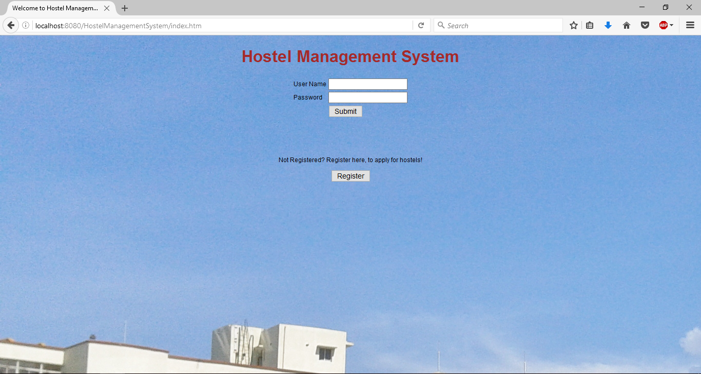

1. After Login:

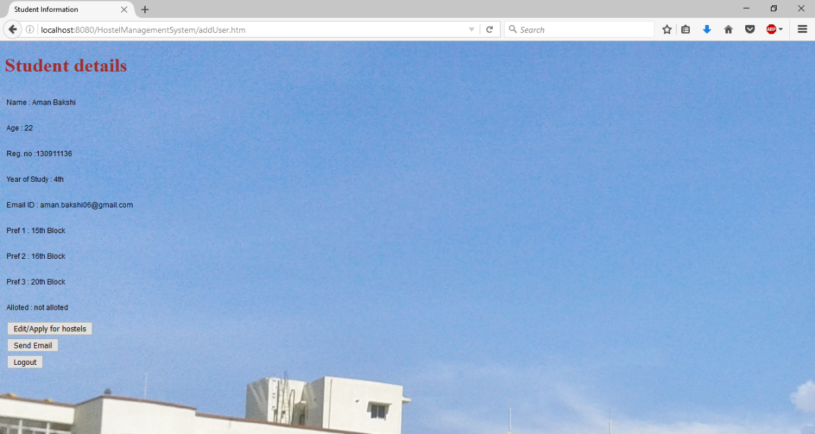

1. Provide hostel preference:

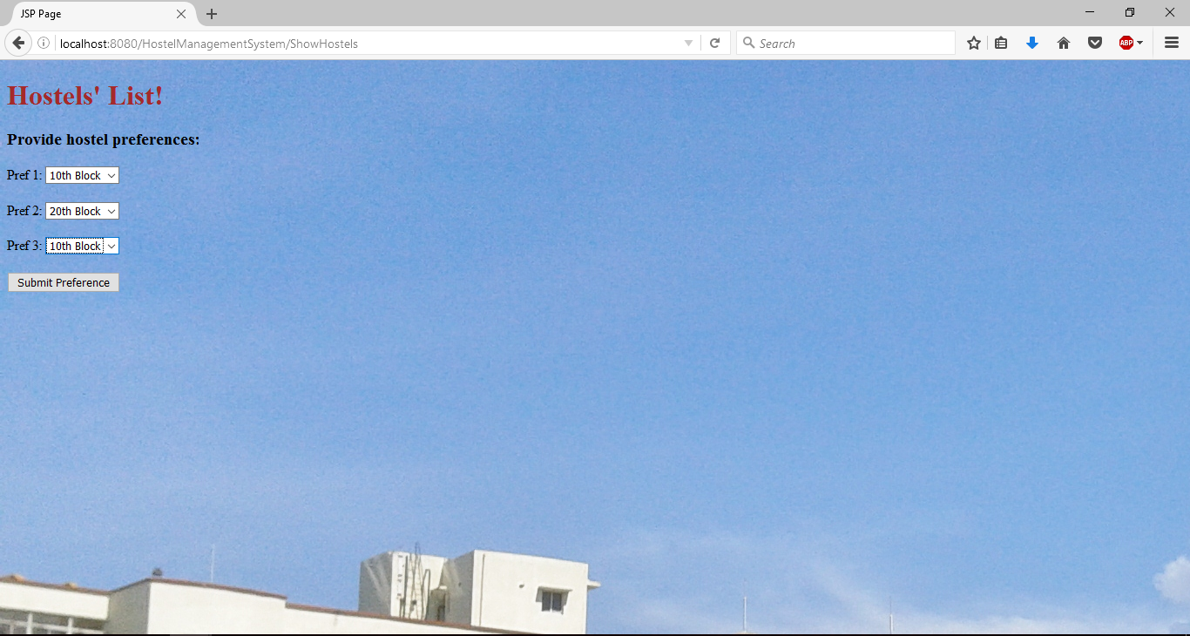

1. Application successful!

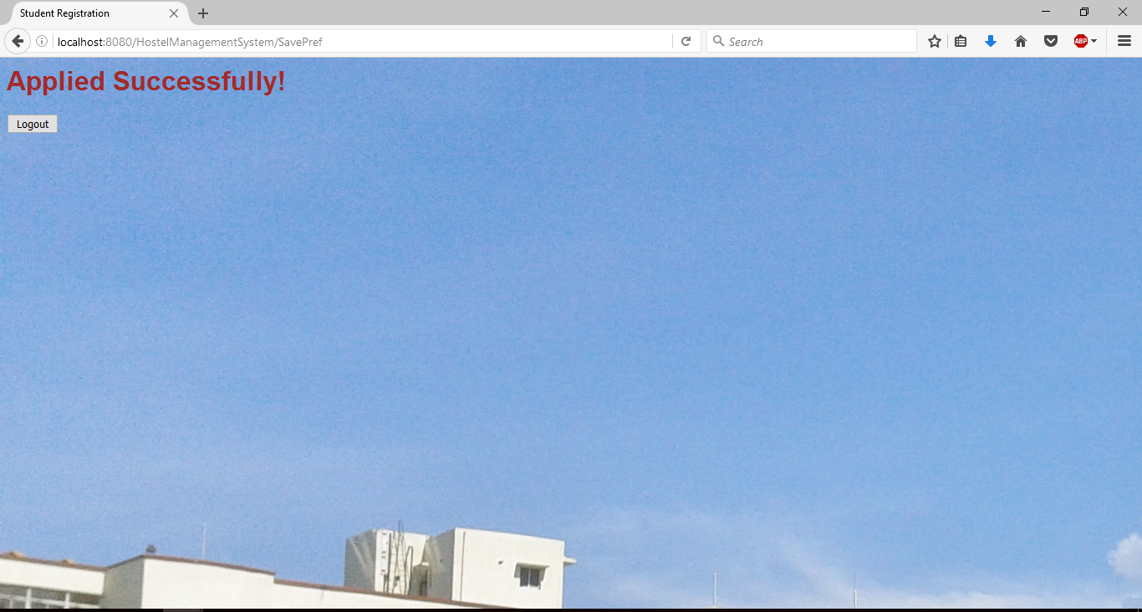

1. Registration:

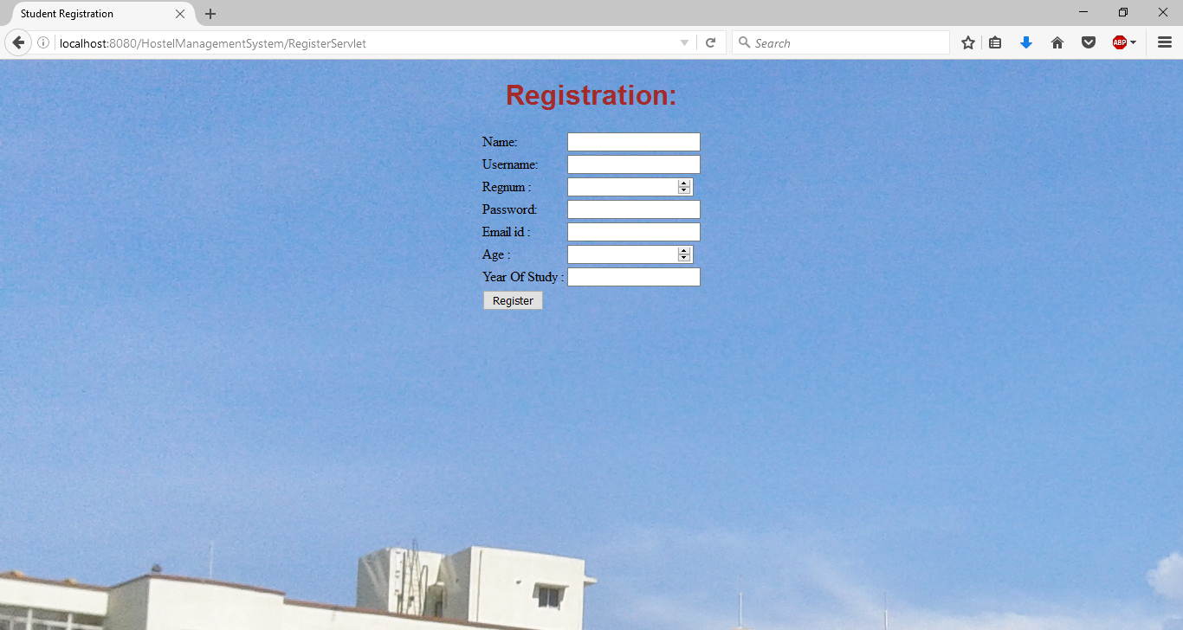

1. Admin’s page :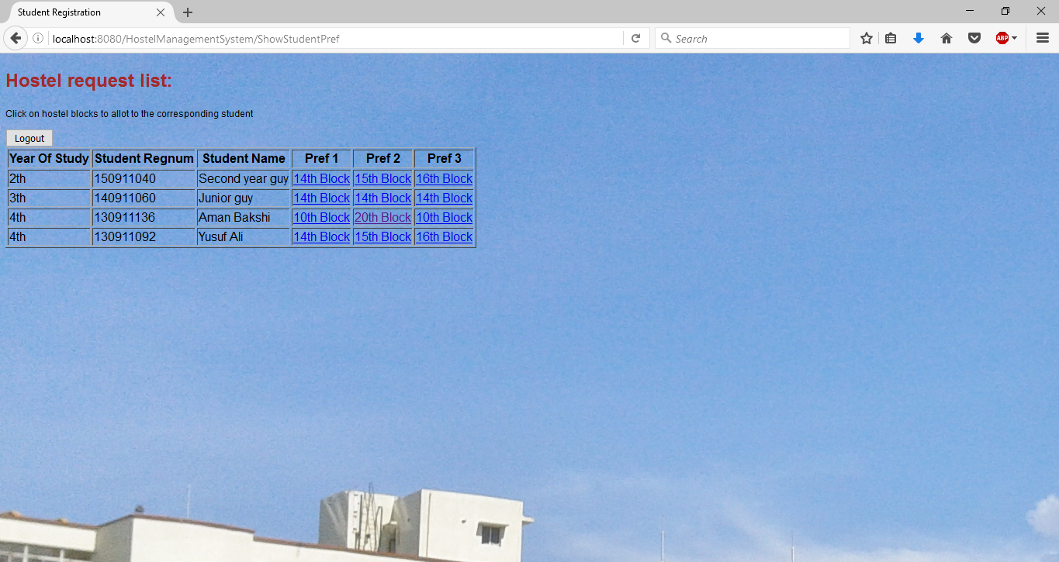

**CONCLUSION**

Rather than designing manually we have made use of computer as once that data are input it performs accurate function. There is no chance of fault or miscalculation if the data are fed correctly. Use of the computers has solved many problems, which are faced while annual calculation. This is not the end but beginning of the versatile, efficient and out-sourcing hostel reservation system. This is the one which is compatible to all operating system. By making this we project we made a small footstep towards the path of progress of platform independent hostel reservation system.

Future Enhancements:

* Extra and user defined security needs can be employed during request and response.
* Records of client activities can be maintained.
* Another enhancement would be to add more modules to cover all information off the system

**REFERENCES**

***WEB***

[1] https://www.tutorialspoint.com/spring/spring_web_mvc_framework.htm

[2] http://www.theserverside.com/news/1364527/Introduction-to-the-Spring-Framework

[3] https://www.tutorialspoint.com/jsp/jsp_page_redirect.htm

[4] http://www.java2novice.com/spring

.